Structure of the portfolio

MESR = Portfolio of 6000 words. Each LO is weighted at 18% (90%) with academic tools and referencing at 5% each (total = 10%)

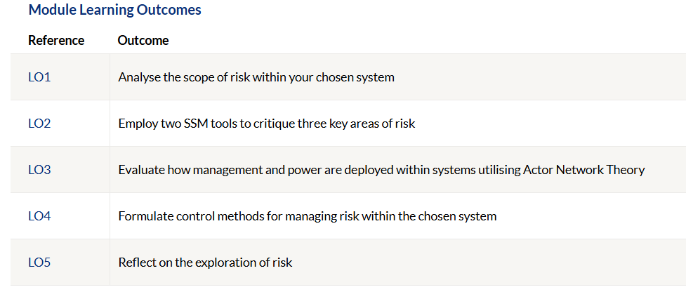

1a) What is your system and how does risk factor in?

(600 words. Choose from PM, H&S or Resource Management and focus on risk etc. Explain with evidence wherever appropriate in the appendix).

1b) As part of the scoping analysis seek to explore what SSM tools can be used.

(600 words. Discussion about what they are. (Steer toward rich picture and fishbone diagram as best options - but can also use CATWOE and root cause analysis tool (RCA)).

2a) Pick two SSM tools and critique them

(600 words. Steer towards rich picture and fishbone diagram as best options - but can also use CATWOE and root cause analysis tool (RCA)).

2b) Apply the two tools to three key areas of your system. What initial issues can you see with your system?

(600 words. Short section linked to appendix highlighting their use and a reflection on how it was doing them do not start analysing yet here - That comes section 4).
3) What is actor network theory? How can it be seen in your system?

(1200 words. Explain and explore ANT - human/non-human actors, agency/power, interessement, hidden messages and using the rich picture again develop it to include these things hidden within (see appendix) that you didn't realise first time round!)

4) Pick three areas of risk within your system and analyse strengths and weaknesses whilst incorporating possible control methods to address them.

(1200 words. Considerations could be management, managerial decision making, processes, data capturing, audits, IT/tech, quality, risk management, power/politics etc and have a critical analysis chat on 3 of these pulling apart the system with SSM tools and authors views).

5) Reflect upon what you have learned about SSMs and SSMs tools, the role of Actor Network Theory and your journey within the module investigating risk within a system. You can also reflect on risk experiences during your engineering career and make recommendations.

(1200 words. Does exactly as it says on the tin).

Additional considerations

This is a whole thought process, pick a system, pick your tools, who are involved, identify strengths and weaknesses, control methods and reflect. (PDCA)

Reference list (not references) needs to follow the 3rd edition Harvard Referencing Handbooks verbatim (there is the introduction booklet as well as the actual handbook). This is an easy place to pick up marks but also consider how they are using the in-text citations as well if you are intending on awarding higher marks.

